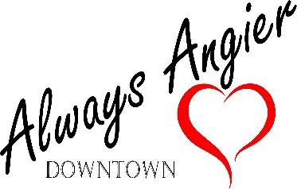
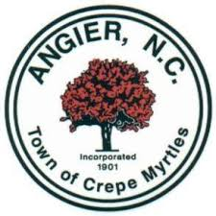
Town of Angier
55 N. Broad St. W.
Angier NC 27501
919-639-2071

Lewis Weatherspoon Gerry Vincent
Mayor Town Manager

Main Street Advisory Board Meeting Minutes
November 21, 2019

Meeting called to order at 6:30 p.m.
Present:
Rachel Barnes Board Member
Jim Nicholson Board Member
Gail Turner Board Member
Professor Banks Guest – Professor at Campbell University
(Minor Child) Banks Guest – Son of Professor Banks and Boy Scout
Christy Adkins Downtown Manager

- Minutes from October 17th approved.

- Committee members were provided with updated Main Street informational documentation.

- Brick sales were discussed.

- Marketing of downtown, downtown themes and branding were discussed.

- Forming subcommittees and the importance of creating a volunteer network were discussed.

Meeting Adjourned

