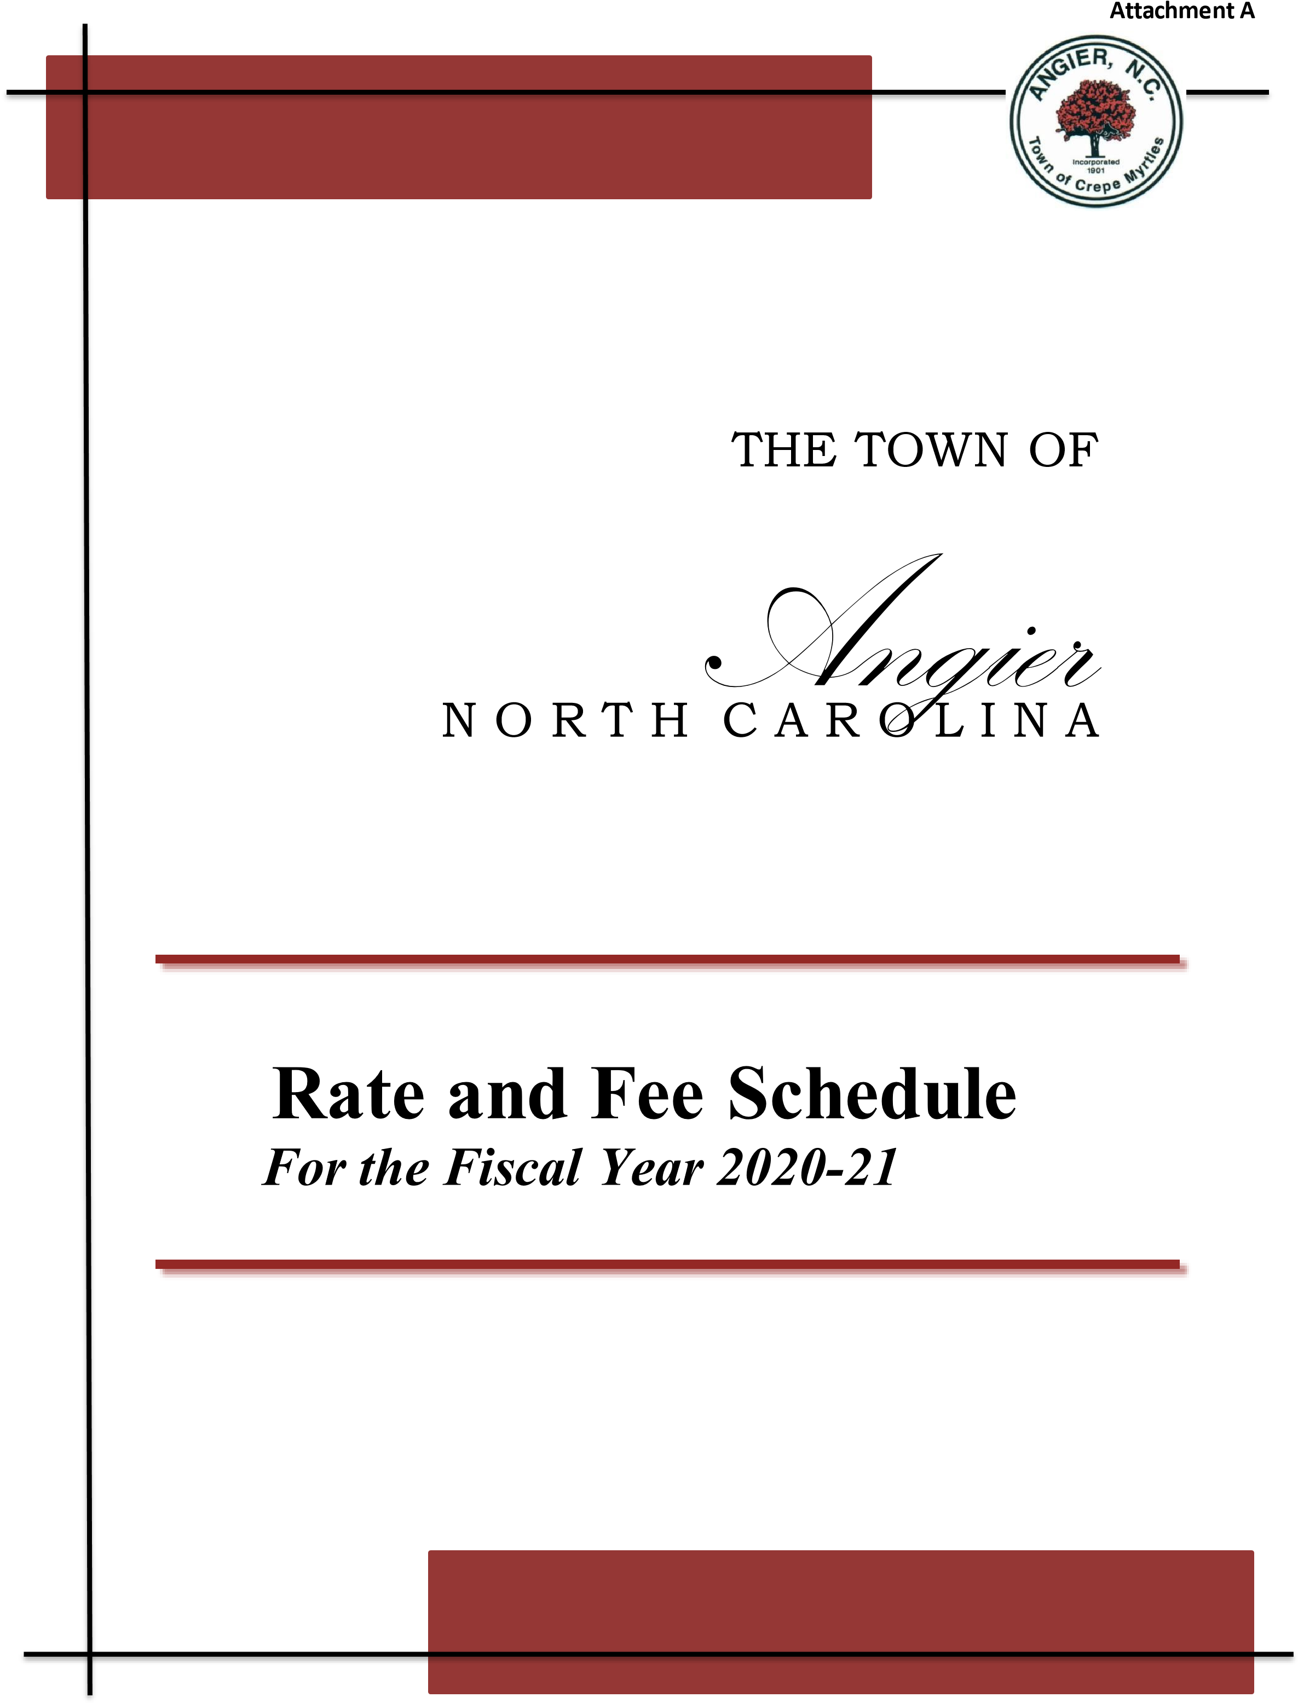
2021-2022

Property Tax Rate:

Per $100 of valuation $ 0.53
Vehicle Fees $ 10.00

Privilege License Taxes

Privilege License Taxes are the excise taxes placed on a business for the privilege of conducting a particular trade or business within the corporate limits of the Town. Licenses are billed annually for existing business and are issued to new business upon their opening.

The taxes listed below are privilege license taxes that are restricted by law.

Beer (On-premises) |  |  |  | $15.00
Beer (Off-premises) |  |  |  | $ 5.00
Wine (On-premises) |  |  |  | $15.00
Wine (Off-premises)  Recreation Fees: |  |  |  | $10.00
In Town Residents |  |  |  | $25.00
Out of Town Residents |  |  |  | $50.00
Late Registration Fee  Depot Rental: |  |  |  | $10.00
 |  |  | In Town Residents |  | Out of Town Residents
Depot Rental |  |  | $200.00 |  | $400.00
Depot Deposit |  |  | $200.00 |  | $200.00
Note: Civic and non-profit organizations receive a 50% discount on Depot rental.
Animal Control Fees:

First Offense – Warning | No Fee
Second Offense – Civil Summons | $75.00
Third Offense – Civil Summons | $150.00
Fourth Offense – Civil Summons | $350.00
Fifth Offense & Above – Civil Summons  Miscellaneous Fees: | $500.00
Copies  Returned Check Fee  Online Return Processing Fee  Police Reports | $ 0.25 per page  $25.00  $ 4.00  $ 5.00

Planning Fees

Board-related Fees
(related costs include but are not limited to
 | advertising fees and postage)  Annexation Requests |  | $250.00 plus advertising costs
 | Rezoning |  | $400.00 plus any related costs
 | Special Use Permit |  | $500.00 plus any related costs
 | Variance |  | $400.00 plus any related costs
 | Ordinance Text Amendment |  | $400.00 plus any related costs
 | Street renaming (buying new road signs and  County 911 re-addressing) |  | $400.00 plus any related costs
 | Copies of Maps |  | $10 for 11”x 17”, $40 for 24” x 26” or 36” x 48”
 | Planning Service Fees
 | Zoning Verification Letter |  | $50.00
 | Land Use Permit |  | $35.00
 | Sign Permit |  | $50.00 (each sign)
 | Exempt or Recombination Subdivision Review |  | $50.00
 | Minor Subdivision Review (1-2 Lots) |  | $100.00
 | Minor Subdivision Review (3-5 Lots) |  | $200.00
 | Major Subdivision - Preliminary Review |  | $300.00 plus $5 per lot
 | Master Plan Review (Planned Development) |  | $300.00 plus $1 per unit
 | Construction Drawings Review |  | $400.00
 | Major Subdivision - Final Plat Review  Site Plan Review |  | $200.00  $400.00
Storm Drainage/Erosion Control Review |  | $350.00
Parks & Recreation Development Fee |  | $500 per lot/unit
Payment In-lieu of Open Space |  | $600 per lot/unit
Accessory Use/Site Addition Plan Review |  | $100.00
Site Plan Revision |  | $100.00
Wireless Communication Facility Application |  | $1,000.00
Small Cell Antenna Application |  | $100.00
Manufactured Home Park Compliance |  | $150.00 (plus $7.00 per lot)
Building Re-Inspection Fee  Public Works Site Re-Inspection Fee |  | $50 per trip  $25 per trip
Manufactured Home Park Re-Inspection |  | $50.00 per trip
Itinerant Merchants, Solicitors, Peddlers |  | $20.00
Renewal or Reapplication Fee |  | $10.00

Permit Fees for Residential Construction

New dwellings – single family, duplex (Includes all trades and attached structures)
Heated and Unheated
Up to 1,200 square feet $500.00 per dwelling
Over 1,200 square feet $500.00 plus $0.25 per square foot over
1,200 square foot

Residential additions
(Sunrooms, bedrooms, etc.)
0 – 600 square feet $200.00 plus trades
Over 600 square feet Same as new dwelling
Multi-family Structures (Containing 3 or (Commercial Project rates)

more attached units)

Mobile Homes $150.00 plus trades

Modular Homes $250.00 plus trades

Moved House $250.00 plus trades

Residential Accessory Structures & Minor
Renovations (Decks, sheds, Remodels, etc.)

0 – 400 square feet
401 – 800 square feet
801 – 1200 square feet
1201 – 2000 square feet Over 2000 square feet

Permit fees for Commercial Construction

$50.00 plus trades
$100.00 plus trades
$150.00 plus trades
$200.00 plus trades
$200.00 plus $0.10 per square foot over
2000 square feet, plus trades

Commercial rates apply to all nonresidential buildings and multi-family units.

Fee for each trade is separate from the total cost of the project.

Project Cost | Fee
Up to $2,500 | $75.00
$2,501 - 5,000 | $100.00
$5,001 – 10,000 | $200.00
$10,001 – 25,000 | $350.00
$25,001 – 50,000 | $500.00
$50,001 – 100,000 | $1,000.00
$100,001 – 200,000 | $2,500.00
$200,001 – 350,000 | $3,500.00
$350,001 – 500,000 | $5,000.00
$500,001 – 750,000 | $7,000.00
$750,001 – 1,000,000 | $9,000.00
Project cost over $1,000,000 | $9,000.00 plus $0.002 of the amount
 | above $1,000,000
Each T-Pole | $60.00
Commercial modular unit any size | $200.00 plus each trade

Trade Permit and Miscellaneous Fees

Permit Type | Description |  | Fee
Electrical Trade | Minimum  200 Amp  400 Amp  TSP  Conditional Power  Sign Electrical |  | $50.00  $60.00  $75.00  $35.00  $50.00 (Commercial Only)  $50.00
Mechanical  Trade | Minimum  Gas Pack  Heat Pump (each unit)  Gas Piping / Tests |  | $50.00  $60.00  $60.00  $35.00
Plumbing Trade | Minimum  2.5 Bath  - Bath  - Bath or greater |  | $50.00  $60.00  $70.00  $85.00
Homeowner Recovery Fund |  |  | $10.00
Daycare and Group Home Annual  Inspection  ABC Permit Inspection  Demolition permit |  |  | $50.00  $50.00
(Commercial and Residential) May require asbestos report |  |  | $50.00
Re-inspection Fees:  1 through 7 violations  8 or more violations |  |  | $50.00  $75.00

**Working without a permit, in violation with State Law, may result in a “Double the Fee” penalty**

Utility Connection

The fee structure for connecting onto the Town of Angier utility system may include any of the following charges:

Regulatory Fees

Regulatory fees allow the customer the opportunity to connect to the town’s water / sewer system. These fees cover the administrative costs for inspection, design and regulatory requirements.

Size | Water Fee | Sewer Fee
5/8”/3/4” water and 4” sewer | $732.00 | $799.00
1” water and 4” sewer | $799.00 | $799.00
2” water and 4” sewer | $1598.00 | $799.00

Regulatory Fees - Paid by builder at time of issuance of building permit.

System Development Fees – Paid by builder at time of issuance of building permit*

*In Accordance with Session Law 2020-61, Effective January 1, 2021

System Development Fees – A charge or assessment for service imposed with respect to new development to fund costs of capital improvements necessitated by and attributable to such new development, to recoup costs of existing facilities which serve such new development, or a combination of those costs as provided in the Public Water and Sewer System Development Fee Act, S.L. 2017-138.

Meter Size Capacity (gpm) Cap. Factor Water Sewer Total Fee

5/8” 20 1.00 $ 665.00 $ 1,994.00 $ 2,659.00

¾” 30 1.50 $ 998.00 $ 2,991.00 $ 3,989.00

1” 50 2.50 $ 1,662.00 $ 4,986.00 $ 6,648.00

1-1/2” 100 5.00 $ 3,325.00 $ 9,971.00 $ 13,296.00

2” 160 8.00 $ 5,320.00 $ 15,954.00 $ 21,274.00

3” 300 15.00 $ 9,976.00 $ 29,914.00 $ 39,890.00

4” 500 25.00 $ 16,626.00 $ 49,857.00 $ 66,483.00

6” 1,000 50.00 $ 33,251.00 $ 99,715.00 $ 132,966.00

Note: All residential meters are charged at the 5/8” rate, and each unit must be metered separately. Irrigation meters are charged based on the actual meter size rate.

Irrigation Fees:

Size | Fee
5/8” tap or  1” tap | $970.00 plus additional meter cost

Note: Irrigation fees are for branch taps off of existing ¾” or 1” water service. If a separate irrigation tap is desired, all applicable fees based on meter size will apply.

Meter Charges:

Size | Fee
5/8”/3/4” water meter | $366.00
1” water meter | $399.00
2” or larger water meter | Cost of meter and fees

Note: If a road bore is required by the Town, there will be an additional fee as determined by the Town Manager or his designee.

Water and Sewer

Water has a base allowance for the first 2,000 gallons and a variable rate for each additional 1,000 gallons. Sewer is assessed a flat rate and is metered at the first gallon of usage.

 | Water/Base | Water/Variable | Sewer/Flat | Sewer Per 1,000
In Town Residents | $19.80 | $3.99 | $16.00 | $6.61
Out of Town Residents | $39.60 | $7.98 | $32.00 | $12.30

Water Deposits – The deposit is required for those residents who are not property owners. Residents should present a valid social security card. Deposits are refundable and will transfer from a location within the Town’s jurisdiction to another location within the Town’s jurisdiction. Once water service is terminated, the deposit will be applied to the resident’s account balance and any credit balance will be refunded to the resident.

Water Deposit $150.00 (If SSN is submitted)
$300.00 (If SSN is NOT submitted)

Water Service Fees – Service fees are not refundable.

Water service cut on/transfer fee |  |  |  | $50.00
Illegal cut on fee (Tampering Fee) |  |  |  | $50.00
Late Fee |  |  |  | $10.00
Disconnect Fee  Trash Service Rates |  |  |  | $50.00
Residential |  |  |  | $8.31
Commercial |  |  |  | $13.97
Recycle |  |  |  | $4.67

Adjustment Policy:
Leak and break adjustments – all customers are allowed three (3) sewer adjustments in any one calendar year. You must provide the Town with a statement of repair from a plumber. In the event that the resident or landlord repairs the leak, a receipt showing the purchase of plumbing supplies and a statement from the individual who actually made the repair must be provided to the Town. Hanging toilets are NOT eligible for adjustments.

Delinquent Accounts:
Meters are read and bills are calculated on a monthly basis. Bills are mailed on the last working day of each month. Account balances are always due on the tenth (10th) day of the month. There is a grace period, which allows bills to be paid on the twentieth (20th) day of the month without a late fee. If balances are unpaid after 5:00pm on the 20th day of the month, or the Monday after (if the 20th falls on a weekend), a $10.00 late fee will be applied on each account. If the balance has not been paid by 5:00pm on the 25th of the month or the Monday after (if the 25th falls on a weekend), the following late/disconnect fees apply:

1st Late Fee/Disconnection | $50.00
2nd Late Fee/Disconnection | $50.00
3 or more disconnections within a calendar year | $50.00

Your account will final out after 10 days of disconnection if service has not been restored and your deposit (if applicable) will be applied to the balance on the account. If service is restored after the 10 day disconnection period, a new deposit ($125.00) and connection fee ($35.00) will be required. If service is disconnected and a meter shows any usage has occurred between the time of cut off and restoration, there will be a tampering fee assessed on the account in the amount of $50.00. The tampering fee must be paid in addition to any other charges that may be due on the account before water service can be restored. The Town is not responsible for bills that are not delivered by the US Postal Service. If you do not receive your bill by the fifth (5th) of the month, you should contact Town Hall at (919) 639-2071 for your balance.

