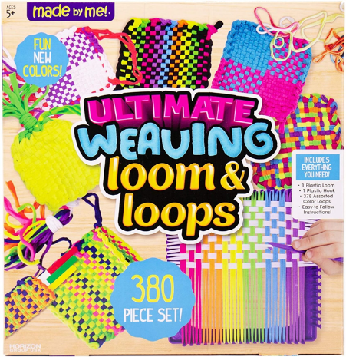

- Weaving Loom
Loom kit that includes the loom, hook, and a variety of loops. You keep the finished products, return the rest back to us.

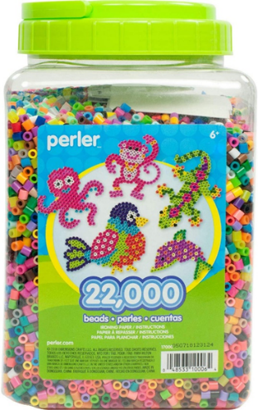

- Perler Bead Kits
Everything you need to create your own Perler bead designs. 3 kits to choose from (shape, animal, people) all including large plates as well. An assortment of beads included with the kit. Keep your creations, and return the rest to us.

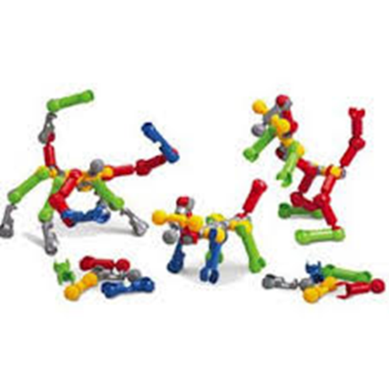
- Zoob Stem Building Set
Kits to build anything your imagination can think of (or you can follow some idea cards). There are 2 sets available.

4. Marble Run
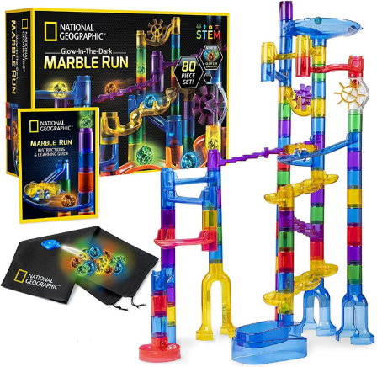

5. Cities of the World Memory Game
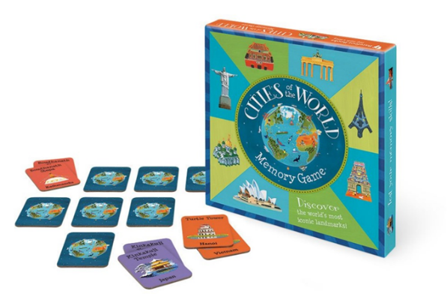

6. Dancing Dinos Dominoes
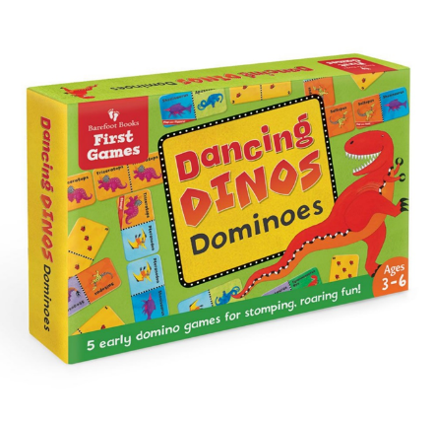
7. Busy Bear Count & Sort
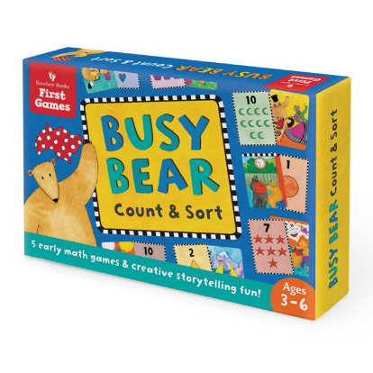
8. Guess in 10 (Animal Planet)

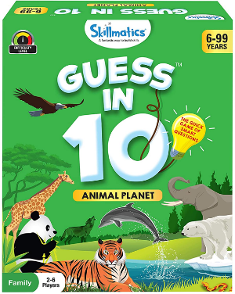

9. Cards Against Humanity: Family

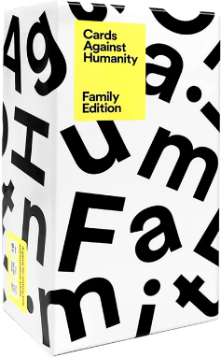

10. Chutes and Ladders

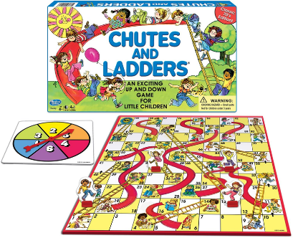

11. Candy Land

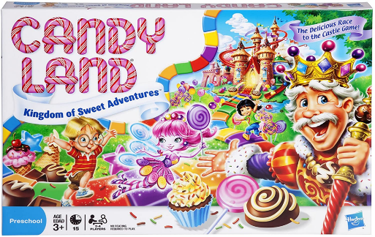

12. Checkers

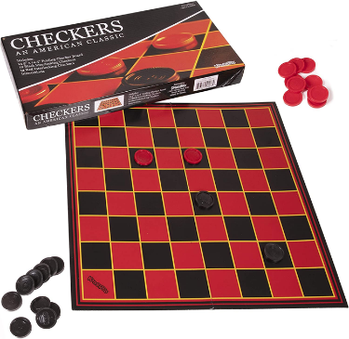

13. Guess Who?

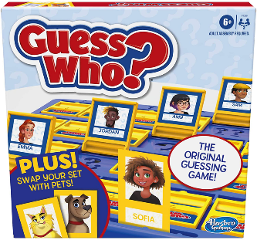

14. Table Tennis

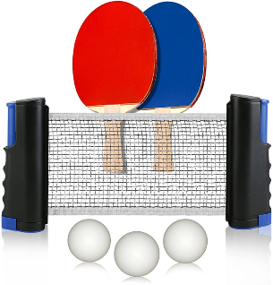

15. Horseshoes

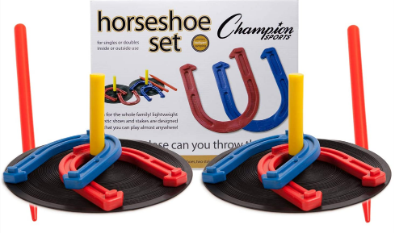

16. Toss and Catch

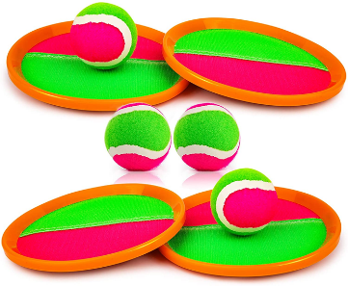

17. Disc Golf (3 sets available)

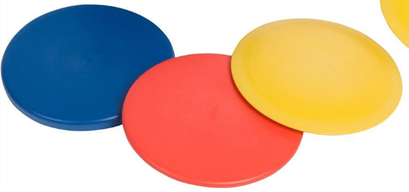

18. Shuffleboard Set

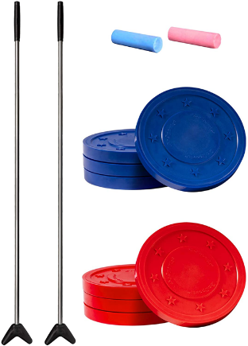

19. Cornhole

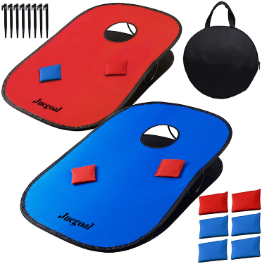

20. Basketball

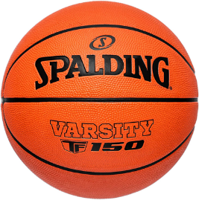

21. Soccer Ball

22. Volleyball

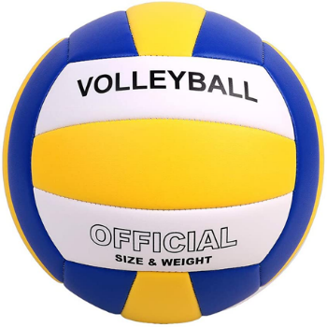

23. 21” Tennis Racquet

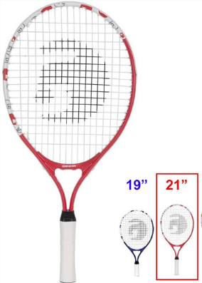

24. 25” Tennis Racquet

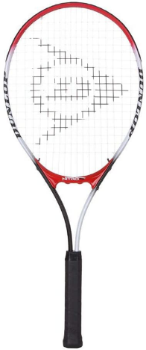
25. Adult Tennis Racquet

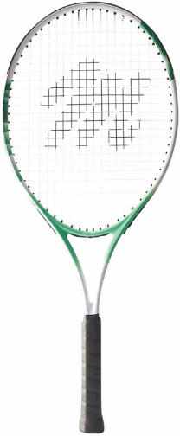

26. T-Ball Glove (L & R) 9.5”
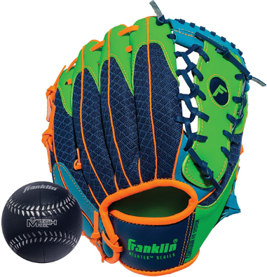

27. 10” Baseball Glove (L & R)
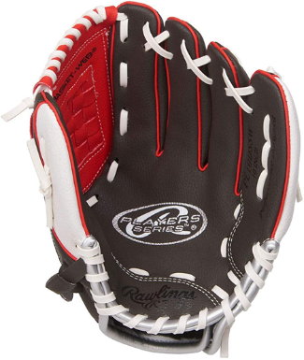
28. 10.5” Right Hand Glove
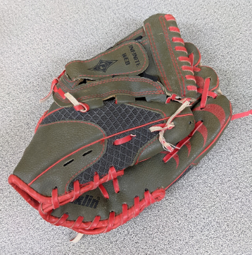
29. 10.75” Right Hand Glove
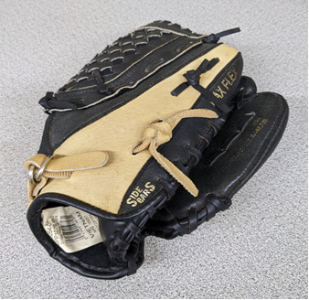
30. Adult Baseball Glove (L & R)
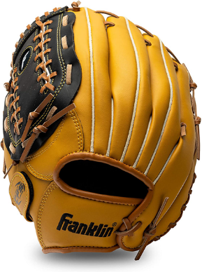

31. Baseball (multiple available)

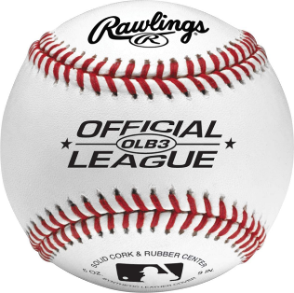

32. Cushioned Safety Baseball (multiple)

