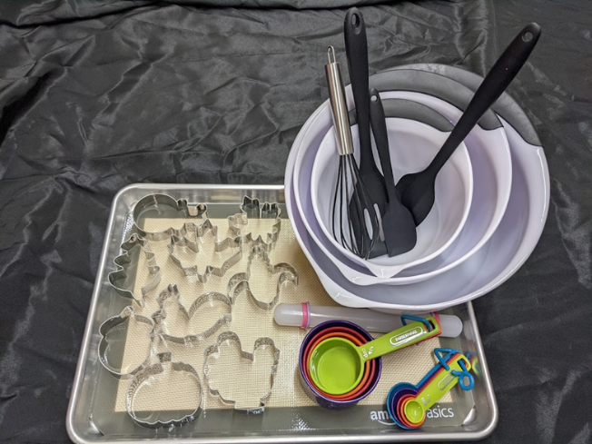

- Cookie Baking Kit
Includes everything you need to
make cookies. Cookie cutters vary
depending on season.

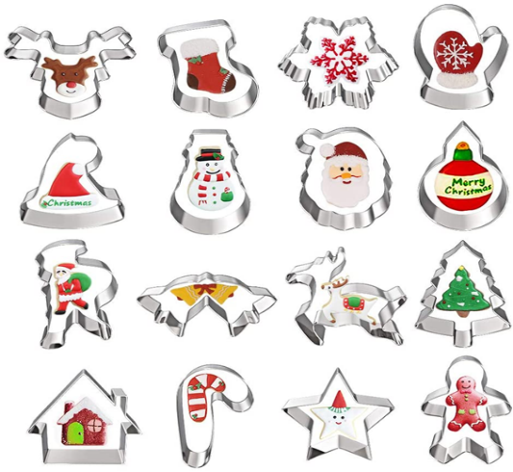

- Christmas cookie cutters
Set of 12 cutters of various shapes.

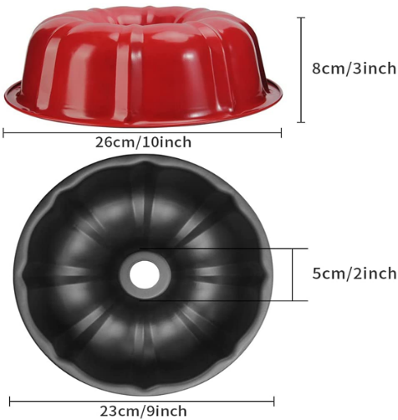

- Bundt Pan
Red 10” bundt pan (2 available)

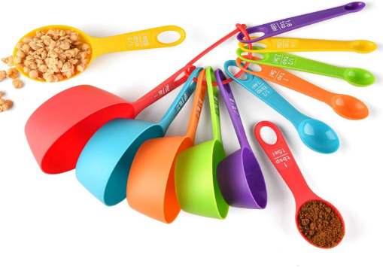
- Measuring cups
Full set of measuring cups and spoons (2 available)

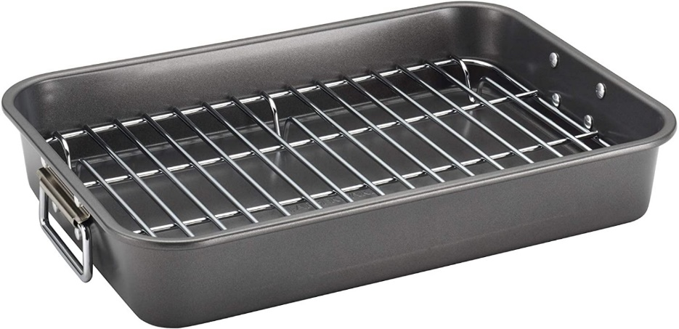

- Roasting Pan
Large roasting pan with wire rack (2 available)

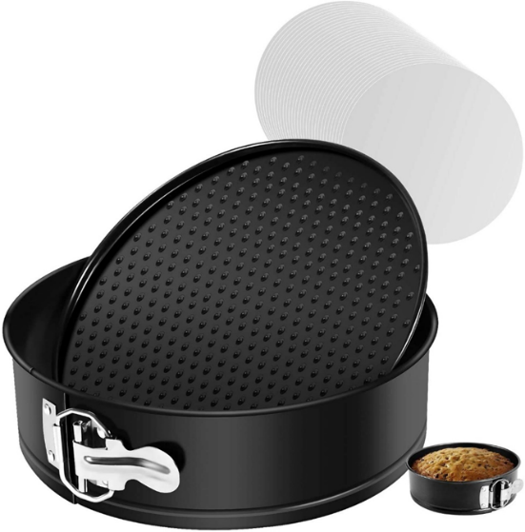

- Springform Cake Pan
9” springform pan with 2 parchment paper liners included

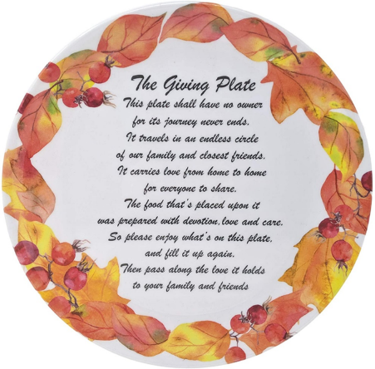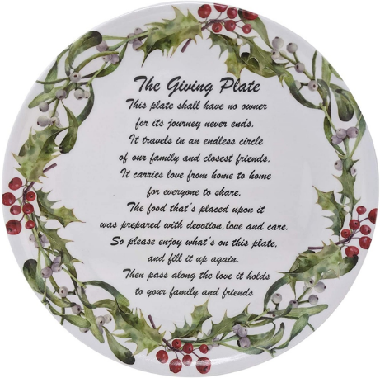

- Holiday Serving Platters
12” round platters for Thanksgiving and Christmas (3 of each available)

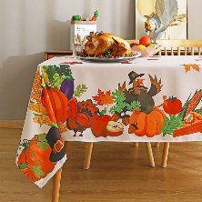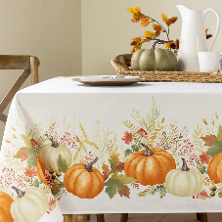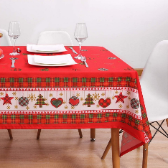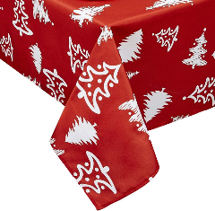

- Holiday Tablecloths
Thanksgiving and Christmas tablecloths, all stain resistant.

